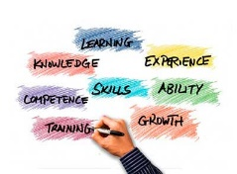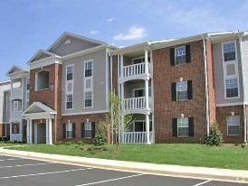

**Community Engagement**

**Academic Enrichment**

GOALS  
FOR THE FUTURE  
FROM THE 5 AREAS

Star Quality

Star Quality

Star Quality

Star Quality

Star Quality

Star Quality

Star Quality

Star Quality

Star Quality

Star Quality

ACTION STEPS

ACTION STEPS

ACTION STEPS

ACTION STEPS

ACTION STEPS

**Career Development**

**Independent Living**

**Self-Determination**