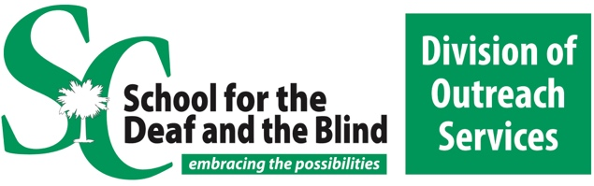

Virtual Presentation with Lily Slavin
Doctoral Student at CMU with the CHARGE Syndrome Research Lab
This presentation will provide an overview of the educational experiences of students with CHARGE, including common special education eligibilities, programming, and services received. This presentation will discuss the 5 main domains of educational impact of CHARGE: medical, sensory, communication, developmental, and behavioral. This presentation will provide an overview of the Educational Checklist, a published tool used to aid in meeting the needs of students with CHARGE at school.

WHO | Lily Slavin
DATE | November 18th
TIME | 1:30 - 3:00 Central 2:30- 4:00 Eastern
HOSTS | The South Carolina Deaf-Blind Project  The Kentucky Deaf-Blind Project  The Tennesse Deaf- Blind Project

Biography:
- Lily Slavin is a fifth-year doctoral candidate in the school psychology PhD program at Central Michigan University. She has worked as a member of the CHARGE Syndrome Research Lab with Tim Hartshorne since 2016. Her research focuses on educational needs and supports for students with CHARGE. She has presented her research to several DeafBlind projects and at CHARGE conferences in Germany, Norway, Australia, Florida, Texas, New York, and Cincinnati. Lily is currently completing her pre-doctoral internship at the Kennedy Krieger Institute

Register Here:

by clicking
Questions or accommodation request, email Trtedder@scsdb.org

