

**Kid’s Chronicle**

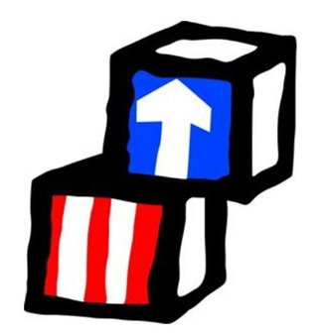



**Monthly Newsletter of LSUHSC Early Head Start Child Care Partnership Program Volume 3 Issue 3**

**Kid’s Chronicle**

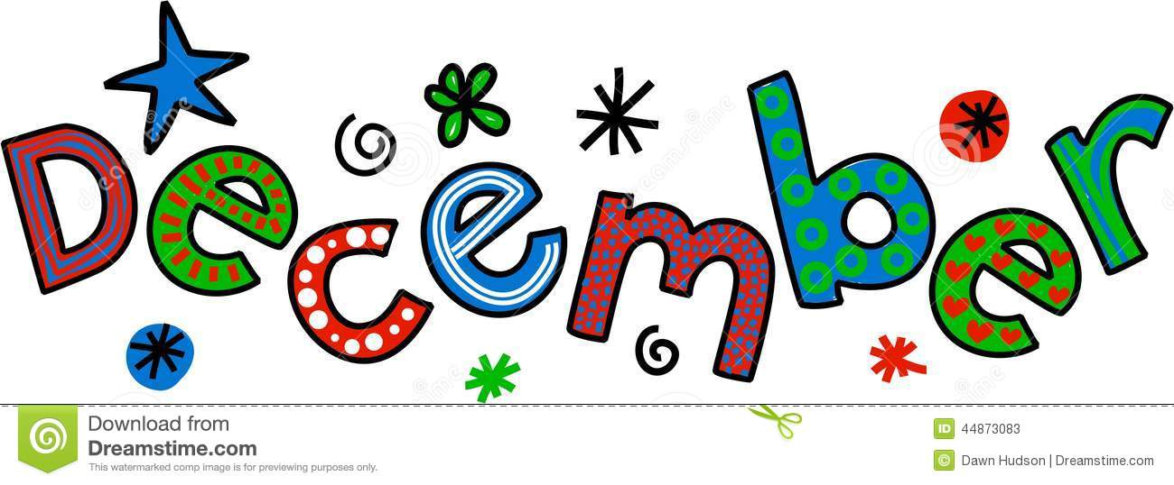









HCI: Oral Health

**CAVITIES (ROTTEN TEETH)**

What is a cavity? A cavity (also called tooth decay) is a hole in your tooth that happens when your tooth begins to rot.

How do cavities form? We know that germs live in our mouth. The germs use sugar to grow and make acid. The acid is what puts a hole (cavity) in your tooth. Remember that foods that have sugar cause cavities! Eating foods that are good for you, brushing and flossing regularly, and visiting your dentist can help prevent cavities.

How do you prevent cavities?

Brushing and Flossing

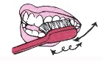 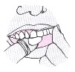

MCj02907430000[1] Brush twice a day and floss once a day.

MCj02907430000[1] Place the toothbrush on your teeth at a slight angle toward your gums. Brush the sides of your teeth and gum line gently, moving the toothbrush in small circles for 3 minutes.

MCj02907430000[1] It’s important to brush all three sides of your teeth: the top side that mashes your food, the inside closest to your tongue, and the outside closest to your cheek.

MCj02907430000[1] To floss, pull a long piece of floss from the box. Next, wrap the floss gently and lightly around your middle (third) finger on each hand. Put your hands a few inches apart and hold the floss between them in a straight line. Slide the floss gently between your teeth. Move the floss up and down gently in a C shape, following the shape of the tooth to clean.

MCj02907430000[1] Begin brushing when baby’s first tooth appears. Use a wet, soft, child-sized toothbrush to clean them. Do this in the morning and at night before bed.

REMEMBER:

You are your child’s most important teacher for life! Your children can be healthier all because of you!

**HAPPY HOLIDAY SEASON TO EVERYONE!**

The LSUHSC EHS-CCP Staff can hardly believe that December is here, the school year is flying by! During this time of year we spend lots of time with our family and friends, sharing traditions and creating new memories. This year, let’s make it a tradition to give your kids the gift of a memorable holiday experience. It's amazing how much kids value and remember family traditions. Unlike anything else, family traditions are a source of fun, they strengthen family bonds and they form a meaningful link to the past. Whether you're baking cookies, watching a favorite holiday movie or piling into the car to look at neighborhood lights, don't underestimate the value of time spent together enjoying each other's company.

We know during this time of the year children will be traveling to spend time with love ones. Parents be sure to inform your EHS Coordinator in writing if you’re planning to be out for an extended period of time. Also, please be sure to check your EHS operational calendar for early dismissal and holiday closures.

**Instructions:**

1. **Glue, place, and stick** your plastic figurine to the inside of the jar lid.
2. **Fill your jar with water** and/or glycerin and add glitter—1-2 teaspoons.
3. **Screw the lid on the jar** — glue it if you're concerned about your child trying to open it.

**That's it!**

**Shake your jar to make it snow!**

**Homemade Snow Globes**

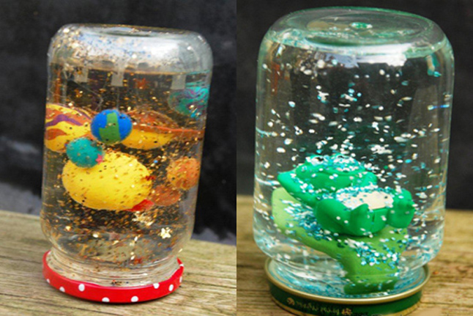

**Materials:**

* small glass jar
* small plastic toys
* glycerin (optional: while it's not necessary, it makes the glitter float better)
* glitter
* water
* glue (we used a hot glue gun, but superglue should work too)



**1. Anthropologie Canal Place (Seasonal)**

Sales Associates (Apply atwww.WorkNOLA.com)

**2. Brooke Companies**

Receptionist /Administrative Assistance

To apply email your updated resume to generaloffice@brookecompanies.com and title your email, "Work NOLA- Recept/Administrative Assistant - 103730".

**3. Edgar P. Harney Charter School**

Substitute Instructor

If you have experience working with students in a school setting, please submit your resume to [lynn.polk@soeanola.com](mailto:lynn.polk@soeanola.com).

**4. Express Employment Professionals of New Orleans**

Event Staff at Convention Center

(Apply atwww.WorkNOLA.com)

**5. Hurwitz Mintz Furniture Company**

Furniture Delivery Driver

Apply in person at 1751 Airline Dr., Metairie, LA 70001

**6. Louisiana SPCA** (Apply Online)

•Humane Law Enforcement Dispatcher

•Volunteer Coordinator

<https://www.applicantpro.com/j/679470-91432>

**7. Neyow’s Creole Café** (IMMEDIATE HIRE)

•Host/Hostess

•Food Runner

•Server

**8. Uptown Eye Care**

Optical Sales Associate (Apply atwww.WorkNOLA.com)

**9. W Hotel New Orleans-French Quarter**

Guest Services Representative

To apply visit:

<https://marriott.taleo.net/careersection/2/jobdetail.ftl?job=17002CFB>

**10. Sheraton New Orleans Hotel**

Housekeeping Supervisor

To apply now, go to: <https://marriott.taleo.net/careersection/2/jobdetail.ftl?job=17002BVP>

**11. UPS** (Apply at www.jobs-ups.com)

•Package Handler NOLA- (Part time)

•Seasonal Personal Vehicle Packages Driver (HARVEY)



Kid’s Kingdom Academy and Pastor & Mrs. Bernard Waters partnered together to give back to the community by sponsoring their first Feed the Community event on Saturday, November 18, 2017. Together, they were able to show their appreciation for the community by providing food and clothing donations.

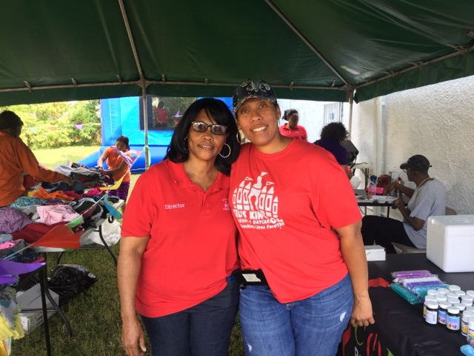



**Tips for Choosing Toys for Toddlers**

**Choose toys that can be used in a variety of ways.** Toddlers love to take apart, put back together, pull out, put in, add on, and build up. Choose toys that are “open-ended” in the sense that your child can play many different games with them.

1. **1. Look for toys that will grow with your child.**

* Plastic toy animals and action figures, toddler-friendly dollhouses, trains and dump trucks (and other vehicles), stuffed animals and dolls

1. **2. Select toys that encourage exploration and problem-solving.** Puzzles, shape-sorters, blocks, nesting blocks or cups, art materials like clay, paint, crayons or play-dough
2. **3. Give your child the chance to play with “real” stuff—or toys that look like the real thing.**

The all-purpose large cardboard box is always a big hit for toddlers and is free. Boxes become houses, pirate ships, barns, tunnels—anything your child’s imagination can come up with!

1. **4. Toss in some “getting ready to read” toys.**
2. **5. Seek out toys that encourage your child to be active.**

* Balls of different shapes and sizes, tricycles or three-wheeled scooters (with appropriate protective gear), plastic bowling sets, child-size basketball hoop, pull-toys

1. **6. Look for toys that nurture cross-generational play.**

As your child approaches age 3 and beyond, early board games—that involve using one’s memory or simple board games that do not require reading—are fun for all ages to play. Consider starting a **“family game night”** when all of you play together

**For more parenting resources, please visit** www.zerotothree.org

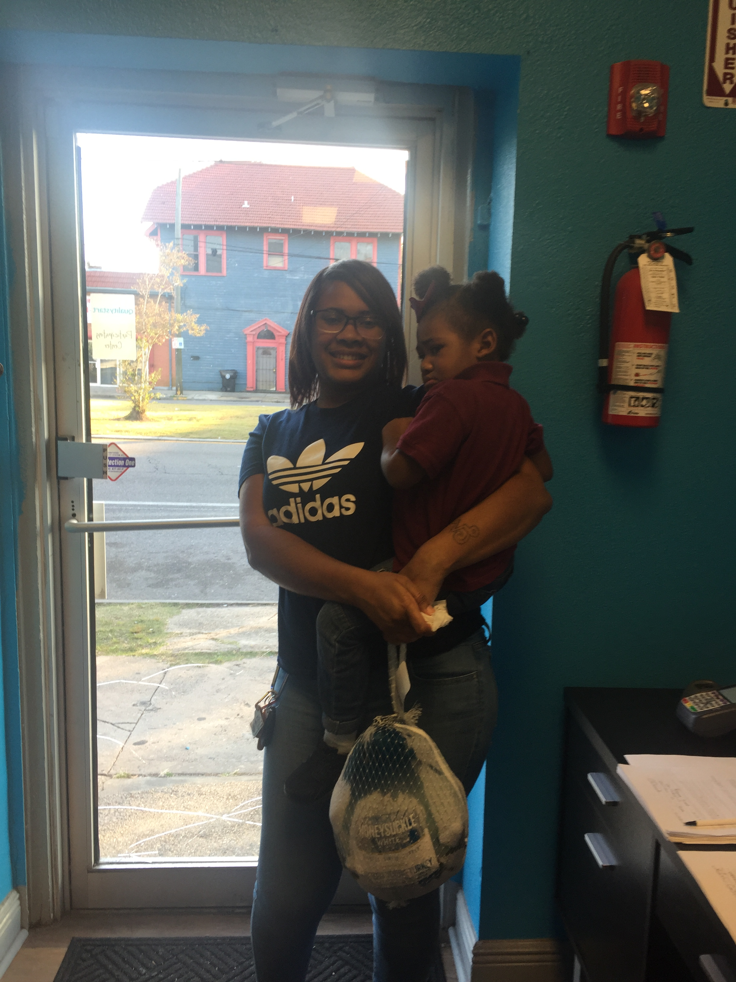

This year, Toddler’s University was able to give each of their families a turkey for the Thanksgiving holiday. Their kind gesture put smiles on their families’ faces and made the holiday even more special.

PARTNER SPOTLIGHT

