We are honored to spotlight two phenomenal teachers; Ms. Jasmine and Ms. Letitia for their amazing scoring achievements with CLASS. The Classroom Assessment Scoring System (CLASS) is an observation tool that focuses on the effectiveness of classroom interactions among teachers and children.

Ms. Jasmine & Ms. Letitia share their experience with CLASS. “In the beginning of the school year we felt confident but intimidated by CLASS because we didn't fully understand what CLASS was looking for in teachers. After being observed for the first time this school year we realized we needed to learn more about CLASS. We both set goals as well as rules for our classroom, we challenged ourselves and our coaches, we asked questions, researched, we both participated in My Teaching Partner (MTP) pilot program and most importantly we stayed consistent. Having someone look at us and judge our teaching abilities doesn't bother us anymore because this is something we do on a daily basis. Now we are more consciously aware of what we are doing, we have significant gains in teacher and child interactions in all domains. This is something we both wanted to achieve. That's the only way it will work, you have to both want it for yourselves and work together to achieve that goal. Remember, there’s no “I” in team. During our last observation we were more confident in ourselves because we are now better observers of our own teaching practices”.

LET’S KEEP OUR KIDS SAFE!

This year, Child Safety Week takes place Monday 5th to Sunday 11th June 2017, with the theme Safe Children: sharing is caring. We are asking friends, families, communities and professionals to show they care by playing their part in keeping children safe. We all have a part to play in sharing the responsibility for preventing accidents among children.

Medication Safety for Little Kids

Put all medicines up and away and out of sight including your own. Make sure that all medicines and vitamins are stored out of reach and out of sight of children. In 3 out of 4 emergency room visits for medicine poisoning, the child got into medicine belonging to a parent or grandparent.

Even if you are tempted to keep it handy, put medicine out of reach after every use. Accidents can happen fast. It only takes a few seconds for children to get into medicine that could make them very sick. Talk to your kids about medication safety. Even if their medication tastes good, don’t compare it to candy to encourage kids to take it.

Close your medicine caps tightly after every use. Buy medicines in child-resistant packages when you can.

Educate grandparents. Talk to grandparents about being extra mindful with medicine or pillboxes when children are around.

Top 5 Tips to Protect Your Baby
A firm mattress and fitted sheet are all you need for your baby’s crib. Remove blankets and toys.
Learn to use your child’s car seat the right way.
Make sure you have both a working smoke alarm and a carbon monoxide alarm on every level of your home, and in all sleeping areas. Test the alarms to make sure they work.
Place your baby’s crib and other furniture away from windows and blinds. Your baby is safer without any strings or cords within reach.
Set your water heater to 120F to avoid scalds.
Keep small objects such as buttons, beads, jewelry, pins, nails, marbles, coins, stones and tacks out of reach and sight.

Kid’s Chronicle

Monthly Newsletter of LSU Early Head Start Child Care Partnership Program Volume 2 Issue 9

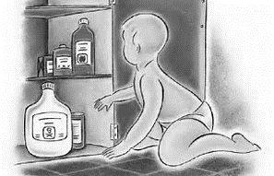


Ms. Letitia Ms. Jasmine
TEACHER SPOTLIGHT
McMillian’s First Steps –The Lion King Classroom

Burn Prevention for Little Kids
Check the water with your wrist or elbow before giving your baby a bath. Don't leave a small child unsupervised in the bathtub, in the kitchen or around electrical outlets.
Kids love to reach, so to prevent hot food or liquid spills, simply use the back burner of your stove and turn pot handles away from the edge.
Don't carry or hold a child while cooking on the stove. Instead, move a high chair in the kitchen within reach or sight before you start. Then talk to your child so they know what's going on. It's a great way to spend time together.
Unplug and safely store irons, flat irons and other appliances that might be hot to the touch.

Top Safety Tips to Protect Your Toddler

Keep small objects such as buttons, beads, jewelry, pins, nails, marbles, coins, stones and tacks out of reach and sight.
Cut food for toddlers into tiny pieces. Children under 5 should not eat small, round or hard foods, including pieces of hot dogs, cheese sticks or chunks, hard candy, nuts, grapes, marshmallows or popcorn.
Consider your child’s age when purchasing a toy or game. It’s worth a second to read the instructions and warning labels to make sure it’s just right for your child.
Before you’ve settled on the perfect toy, check to make sure there aren’t any small parts or other potential choking hazards.

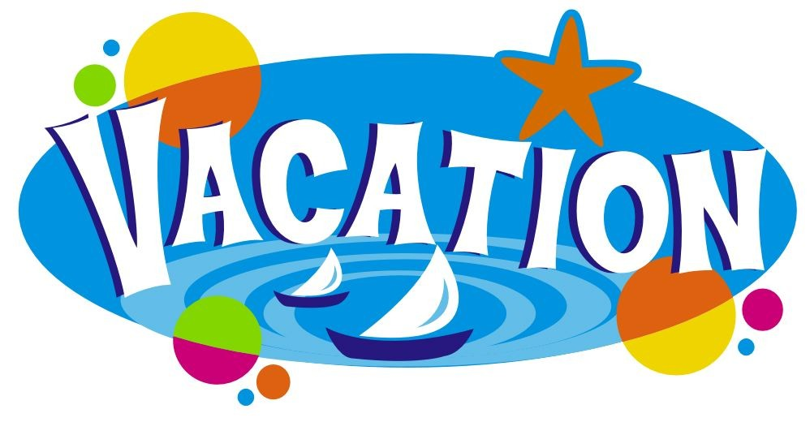
Hurricane Preparedness Tips

Essential Supplies
Important Papers

Protect Your Home
Protect Your Valuables
Prepare for Electrical Outages
Special Medical Needs
Sheltering Your Pets
NORDC
Youth Summer Camp
In 2017 NORDC will offer 41 youth camps (ages 4-12) that will serve over 3,800 kids across the city. For more information contact (504) 658-3049 or email NORDCyouth@nola.gov.
Teen Career Camp
In 2017 NORDC will host 14 Teen Career Camps (ages 13-15) that will serve 1,000 teens across the city. Additionally, teens will earn a stipend of $15 per day, with an opportunity to earn over $400.00 over the six weeks. There will also be a program exclusively for teens with special needs. Space is limited. For more information contact (504) 658-3003 or https://www.schedulicity.com/scheduling/GI7WNN.

Whole Foods | Refresh Project
300 North Broad Street
FREE! Kids Summer Camp
June 26th – 30th
8:30am – 3pm | Ages 8-12
For more information and to register, call 907.382.5914 or email gccmkids@gmail.com Space is Limited!

For more information contact (504) 658-3049 or email NORDCyouth@nola.gov.
.

JUNE DATES

1st -Hurricane Season Starts
1st Policy Council Meeting 4:30pm
5^{th –} 11th Child Safety Week
7th – McMillian’s Early Dismissal 1:00pm
13th – Toddler’s Early Dismissal 12:45pm
16th- Kid’s Kingdom Early Dismissal 2:00 pm
18th Father’s Day
21st - Parent Committee Meeting 4:30p McMillian’s
21st- Parent Committee Meeting 4:15p Toddler’s
28th- Parent Committee Meeting 5:00p Kid’s Kingdom
29th-Parent Committee Meeting 4:00p Clara’s

LSUEHS JULY CLOSURES
July 03-07, 2017 (All Sites)
July 21st – Last Day of School
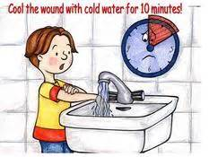


Liberty Lagoon
May 25 – August 6 (OPEN DAILY)
11am - 6:30pm (Mon. –Thurs)
10am -6:30pm (Fri.- Sat)
Noon- 6;30pm (Sunday)

12 Months and Younger (FREE )
Under 48″ tall ($10.00) Over 48″ tall ($12.00)
111 Lobdell Ave
Baton Rouge, LA 70806
225-923-3202

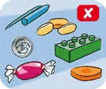
Weather & Emergency Alerts Sign Up
Follow us on Twitter
Connect with us on Facebook
Subscribe to our YouTube channel

http://www.getagameplan.org/
Get A Game Plan APP

