 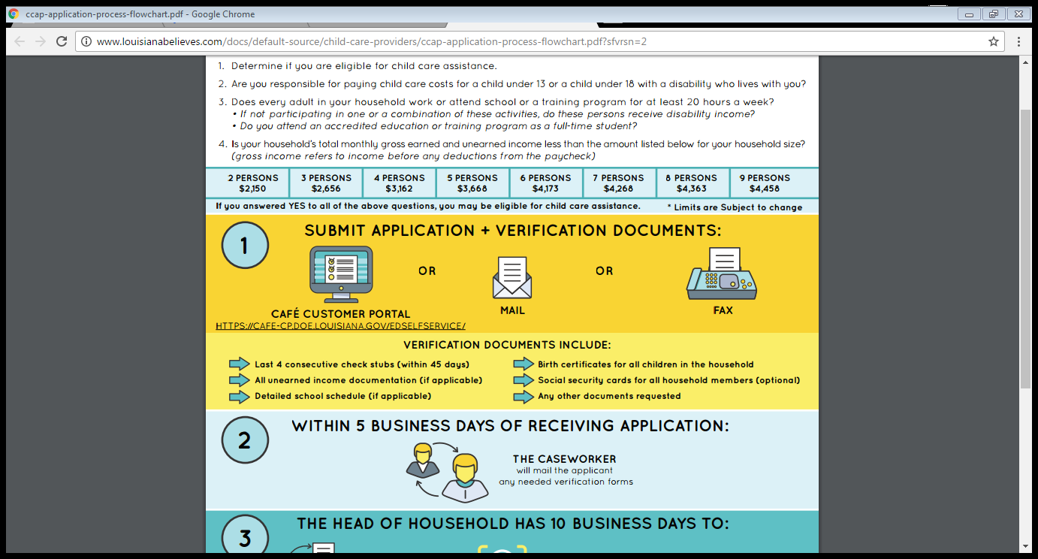

**Education Nation**

As parents and caretakers, we understand the challenges of raising a family and furthering your education. Life doesn’t always allow us the opportunity to do both. However, with the expansion of online and part-time classrooms, now may be the perfect time to go back to school! Here are a few local programs that may offer you the chance to go and earn that certification or degree you deserve:

Delgado Community College (Technical Degrees/Certifications) – Visit <http://www.dcc.edu/academics/technical/>

Loyola University New Orleans (Adult Part-Time Students) – Visit <http://gps.loyno.edu/evening>

Tulane School of Continuing Studies – Visit <http://scs.tulane.edu>

Stevenson Academy of Hair Design – Visit <http://Stevenson-Academy.com>

For more information about financing your education visit studentloans.gov or fastweb.com

*National Autism Awareness Month*

Beyond the April showers and May flowers, April is a marvelous month marked by Autism Awareness. Celebrated annually since the late 1990s, April promotes autism awareness, inclusion and self-determination for all, and assures that each person with ASD is provided the opportunity to achieve the highest possible quality of life. One of the most popular events within the month is the “Light It Up Blue” campaign. Promoted by the Autism Speaks advocacy organization, this particular event involves iconic landmarks around the globe including the Empire State Building, Willis Tower, as well as airports, bridges, museums, concert halls, restaurants, hospitals and retail stores being lit with blue lights to show their support of autism awareness. Not only is the support seen through the community, but many members take to social media and discuss what autism means to them and how we can be more proactive to bringing about awareness to the cause and its wonderful people.

# EHS Meetings & Closures

**Clara’s Little Lambs**

Parent Committee Meeting: Apr. 27th at 4 PM

**Kid’s Kingdom**

Parent Committee Meeting: Apr. 26th at 5 PM

Closed: Apr. 14th |Early Dismissal: Apr. 21st

**McMillian’s First Steps**

Parent Committee Meeting: Apr. 19th at 4:30 PM

Early Dismissal: Apr. 5th | Closure: Apr. 14th

**Toddler’s University**

Parent Committee Meeting: Apr. 19th at 4:15 PM

April 2017 Calendar

**1st – April Fool’s Day**

**2nd – International Children’s Day**

**7th – World Health Day**

**9th – Palm Sunday**

**15th – National Tax Day**

**16th – Easter Sunday**

**22nd – Earth Day**

**April 28th – Arbor Day**

z

2 17

Monthly Newsletter of LSU Early Head Start

Child Care Partnership Program Volume 2 Issue 7

**No Average April**

Home is Where the

Heart Is

Being a first-time home buyer can be a very exciting but confusing time. To make the process a bit smoother, several insurance agencies and housing organizations have come together to offer classes to our home-seeking families. If you or someone you know is looking to buy a home in the near future, let them know about the Family Resources of New Orleans Home Buyer Workshops. Here individuals will learn the ins and outs of the real estate market and know exactly what to look for when purchasing a home. For more information about these classes and the organization, please visit <Http://familyresourcesofno.org>

**Administrative Assistant**

Full-Time

New Orleans East Hospital

New Orleans, LA

Apply at <https://pm.healthcaresource.com/CS>

**Front Office Clerk**

Full-Time

West Jefferson Hospital

Marrero, LA

Apply at <https://pm.healthcaresource.com/CS>

**Store Seasonal Employee**

Part-Time/Full-Time

Lowe’s Home Improvement

Varies Locations

Apply at <http://jobs.lowes.com>

**Patient Coordinator/Receptionist**

Full-Time

South Rivage Dental

Metairie, LA

Apply at Indeed.com

**Retail Customers Service Representative**

Full-Time

FedEx Delivery Service

New Orleans, LA

Apply at <https://careers.fedex.com>

**Mail Handler Assistant**

Part-Time

United States Postal Service

New Orleans, LA

Apply at <http://usps.com/employment>



Do you qualify for the **Child Care Assistance Program**? Want to find out? You can contact our ERSEA specialist, Ms. Raynell, at (504) 556-7535 or at [rwas11@lsuhsc.edu](mailto:rwas11@lsuhsc.edu). We look forward to hearing from you!

**ATTENTION**: ***NEW Eligibility Requirements***

1. Are you responsible for paying child care costs for a child under 13 or a child under 18 with a disability who lives with you?
2. Does every adult in your household work or attend school or a training program for at least 20 hr. /wk.?
3. Is your household’s total monthly gross earned and unearned income less than the amount listed below for your household size?

You may qualify. Visit LouisianaBelieves.com for more information about the CCAP Eligibility Process.

Spotlight Employment