

**2017**

# EHS Meetings & Closures

Policy Council Meeting**-** February 2nd

**Clara’s Little Lambs**

Parent Committee Meeting: Feb. 14th at 3 PM

Closed: Feb. 27th – Mar. 3rd

**Kid’s Kingdom**

Parent Committee Meeting: Feb. 22nd at 5 PM

Early Dismissal: Feb. 17th at 2 PM

Closed: Feb. 27th – Mar. 1st

**McMillian’s First Steps**

Parent Committee Meeting: Feb. 15th at 4:30 PM

Early Dismissal: Feb. 1st

Closed: Feb. 27th – Mar. 1st

**Toddler’s University**

Parent Committee Meeting: Feb. 15th at 4:15 PM

Early Dismissal:

Closed: Feb. 27th – Mar. 1st



**Let’s Talk!**

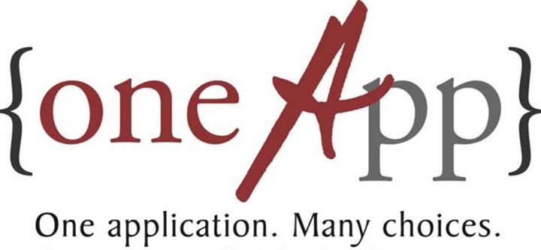

**OneApp Main Round Close - February 24, 2017**

**OneApp Placement Results Available - Week of April 10, 2017**

**EnrollNOLA - OneApp**

[**https://enrollnola.org/**](https://enrollnola.org/)





**A Message from the EHS Director**

Happy February and Lassiez Les Bon Temp Rouler! While this is a very exciting time for the city of New Orleans, we do want our families to remain safe during the festival season. First and foremost, teach your children their name and primary phone number. For very young children, it’s a great idea to mark your child’s clothes with identifiers like name, address and contact information. Keep your children close at all times and discuss with them what to do if separated or confronted by stranger. Be mindful of what your child is standing on and where your family will be watching the parade. Determine what family-friendly events you will go to before leaving home, choose a safe viewing spot, and dress according to the weather. Above all, be safe and have fun!

**Falling in love with February**

[](http://r20.rs6.net/tn.jsp?f=001JNPJqeB7MYqnudVpRXsirV57c6TLF58sTZPjEMv2ZGTfGP5GXGurJASZIMUifVuegJ14hJsDbxsSQsm5ueMBGHhfIMXQoVDMdWUYcbaOJJ0xnnMhaiBxjvTB-0xvq49pcAwktVYBZ-2wm8_4hUSIxyIPmcHnpXhOeJtJ5wl2tnKkXxt6uFb8onzhkY6W_Jh_AJqGY2Dh7iLpvROxuVP6dleRZTAZsY2k5o3TNV_kOSMZcbkUN6KX5WFAB0DVwhCPF8610wEysns=&c=DvjV6fUvGMj4P577xp-h2nUvREgnJ8x25LliR62QAjJHeTWWaKT4cw==&ch=rQt_fknhMKWZOsPL0dClIM9gWzNME19n9SkTcNLeetYgKUZJo-XB7w==)

**On a Mission to Transition!**

The early years of a child’s life are considered the “critical years” for many reasons. The early introduction of educational materials and social experiences help shape our toddlers into the wonderful students, citizens, and adults they will become. In order for our children to make successful transitions from head start to Kindergarten, we need to supply them with the support system they need. Parent participation in transition activities such as getting ready for school, maintaining a positive attitude, and forming healthy day-to-day routines all make a world’s difference when children begin adjusting to their new environments. And while the thought of moving on may seem scary, think of all the wonderful new experience both you and your child will have!

If you need any assistance with transitioning or have questions about how to get started, your EHS family has dozens of resources to help you and your family make a smooth transition. So no fear in the new school year;

go forth and excel!



Monthly Newsletter of LSU Early Head Start

Child Care Partnership Program Volume 2 Issue 6



**Jeremy & Jeremiah**

[](http://www.bing.com/images/search?q=Attendance+Counts+Clip+Art&view=detailv2&&id=DC3282370725ED01BB99BE9A3F425CC42351A2D7&selectedIndex=102&ccid=fWzLj37O&simid=608014362243564627&thid=OIP.M7d6ccb8f7ece43530c96cc3daa1ca21bo0)

**Starbucks** is hiring at **17** locations in the New Orleans area, please visit <https://www.starbucks.com/careers> to apply.

**The 4 Points Sheraton French Quarter location now hiring for the following positions:**

1st Class Stationary Engineer (Boiler & HVAC)

2nd Class Stationary Engineer (Boiler & HVAC)

Overnight Security Officer

Night Audit Manager

Valet Attendant

Room Attendant

Lobby Attendant

Houseman

Line Cook

[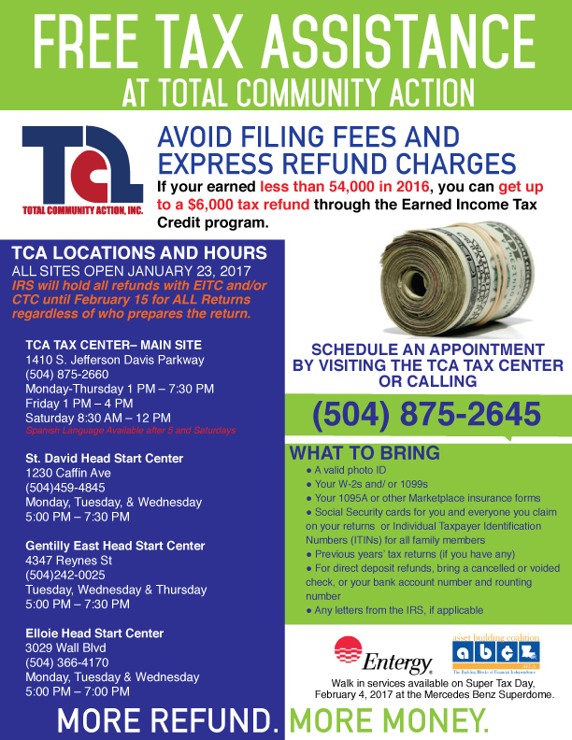](http://www.tca-nola.org/userfiles/2017/01/VITA.jpg)

**University Medical Center NOLA**

**Security Officer** (Varied Shifts) Full time 40hrs. per week, visit www.umcno.org to apply.

**Unit Secretary** -Acute Surgical Care Unit (8-12 Day/Evening) Full time 40 per week, visit www.umcno.org

to apply.

**The Blood Center NOLA**

Human Resources Assistant (full-time), please visit

www.thebloodcenter.org. to apply.

**Banner Chevrolet 5950 Chef Menteur Hwy, NOLA 70126  
Immediate Openings:**

New/Preowned Automobile Salespeople (salary plus commission)  
Experienced Wholesale Parts Sales  
GM Certified Technicians  
Skilled Body Shop Technicians

**For immediate interview please call**: Johnny Brumfield Sr. @

504-253-8487 or Email employment@bannerauto.com







As a friendly reminder, daily attendance is extremely important to you, your child, and our EHS Family. We want your child to benefit the most from his or her time in our program; and in order to do that, we want to see them at the amazing child care centers we partner with. We do understand that circumstances do fall outside of our control; but if your child is healthy and eager to learn, we would love to see them in class! If you have any pressing concerns or questions about your child’s attendance, please feel free to contact our ERSEA specialist,

**Ms.** **Raynell Washington**, at

(504)-556-7537 for assistance. Once again, thank you for being a part of our family!

In the Spotlight

“I hate that my kids have to leave Kid’s Kingdom because I love the school, I love the teachers, Ms. Lynn, and Ms. Rivers. My kids learned so much there. The way they love the kids is priceless. I wish my kids can stay forever!!  Since my kids have been there they have learned numbers, colors, shapes, ABC’s, manners and they are still in the process of being potty-trained. Kid’s Kingdom is amazing and I'm so happy that my kids and I got the opportunity to be a part of their school. I just want to thank you all from the bottom of my heart for everything.”

Much love,

Rajonique, Jeremiah & Jeremy B.