

**A Message from the EHS Director**

Happy February and Lassiez Les Bon Temp Rouler! While this is a very exciting time for the city of New Orleans, we do want our families to remain warm and safe during the festival season. First and foremost, teach your children their name and primary phone number. It’s also great idea to mark your child’s clothes with identifiers like name, address and contact information. Keep your children close at all times and discuss with them what to do if separated or confronted by stranger. Determine what family-friendly events you will be attending, choose a safe viewing spot, and dress according to the weather. Above all, be safe and have fun this Mardi Gras Season!

February 2017 Calendar

**1st– Black History Month Begins**

**2nd – Ground Hogs Day**

**5th – Super Bowl Sunday**

**14th – Valentine’s Day**

**20th – President’s Day**

**27th – Lundi Gras**

**28th – Mardi Gras**

**EnrollNOLA - OneApp**

[**https://enrollnola.org/**](https://enrollnola.org/)

**Let’s Talk**

**One*A*pp**

Is your child transitioning out of the LSU Early Head Start Child Care Partnership Program, this school year? If so, let’s discuss your options!

**For more information, please contact Raynell Washington at 504-556-7537.**



**OneApp Main Round Close - February 24, 2017**

**OneApp Placement Results Available - Week of April 10, 2017**

# EHS Meetings & Closures

**Clara’s Little Lambs**

Parent Committee Meeting: Feb. 23rd at 4 PM

Closed: Feb. 27th – Mar. 1st

**Kid’s Kingdom**

Parent Committee Meeting: Feb. 22nd at 5 PM

Early Dismissal: Feb. 17th at 2 PM

**McMillian’s First Steps**

Parent Committee Meeting: Feb. 15th at 4:30 PM

Early Dismissal: Feb. 1st

**Toddler’s University**

Parent Committee Meeting: Feb. 15th at 4:15 PM

Early Dismissal:



Looking forward to the next school year? Need to get documentation verified?

-----------

**OneApp Verification Event:**

**Saturday, Feb. 4, 2017 – Urban League Schools Expo @ Mercedes Benz Superdome (10 AM – 2 PM)**

**Child Care Assistance Program**

[**https://cafecp.doe.louisiana.gov/edselfservice/**](https://cafecp.doe.louisiana.gov/edselfservice/)

**Falling in love with February**

2017

Monthly Newsletter of LSU Early Head Start

Child Care Partnership Program Volume 2 Issue 6

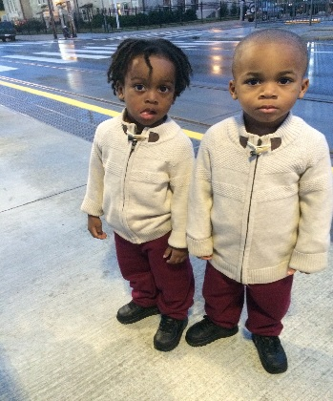

**ATTENTION!**

As a friendly reminder, daily attendance is extremely important to you, your child, and our EHS Family. We want your child to benefit the most from his or her time in our program; and in order to do that, we want to see them at the amazing child care centers we partner with. We do understand that circumstances do fall outside of our control; but if your child is healthy and eager to learn, we would love to see them in class! If you have any pressing concerns or questions about your child’s attendance, please feel free to contact our ERSEA specialist, Ms. Raynell Washington, for assistance. Once again, thank you for being a part of our family and we look forward to working with you in the coming months.

**All the events you need to know!**

**Get Up & Go…**

**All the events you need to know!**



On a Mission to Transition!

The early years of a child’s life are considered the “critical years” for many reasons. The introduction of educational materials and social experiences help shape our toddlers into the wonderful students, citizens, and adults they will become. Therefore, in order for our children to make successful transitions from head start to Kindergarten, we need to be there to supply them with the support system they need. Parent participation in transition activities such as getting ready for school, helping children maintain a positive attitude, and forming a healthy day-to-day routine all make a world’s difference when helping children adjust to their newfound environment. And while the thought of moving on may seem scary, think of all the wonderful new experience both you and your child will have. Additionally, if you need any assistance with transitioning, there are dozens or resources you may use to help So no fear in the new school year!

In the Spotlight

“I hate that my kids have to leave Kid’s Kingdom because I love that school. I love the teachers, Ms. Lynn, and Ms. Rivers. My kids learned so much there. The way they love the kids is priceless. I wish my kids can stay forever!!  Since my kids have been there they have learned numbers, colors, shapes, ABC’s, manners and they are still in the process of being potty-trained. Kid’s Kingdom is amazing and I'm so happy that my kids and I got the opportunity to be a part of their school. I just want to thank you all from the bottom of my heart for everything.”

Much love,

Rajonique, Jeremiah & Jeremy B.