



A wise woman once said, “**Be thankful** for what you have [and] you’ll end up having more. Concentrate on what you don’t have and you’ll never, ever have enough.” That wise woman is none other than producer, actress and philanthropist Oprah Winfrey. Known for her charismatic personality and charitable spirit, Oprah knows a thing or two about showing **thanks** and **appreciation.**

In the midst of the holiday hustle and bustle, we often overlook the little things. Consumed by what to cook, what to wear, and what gifts to buy, we fail to acknowledge the most valuable gift of all: **quality time**. Quality time is a rare and priceless gift that keeps giving long after holidays are over. Whether building ginger bread houses with the kids, watching the local light shows, or decorating the home with handcrafted ornaments, every second counts when making a lifetime of memories. Moving beyond family, we should also take a moment to reach out to those who won’t be with us for the holidays. Taking a few minutes to call a distant relative--or even making your way around the neighborhood visiting good friends--**can make all the difference** in your season and theirs. Sometimes you just don’t need a reason to spread the holiday cheer.

Thus, as 2016 comes to an end, we ought to take a moment to **recognize all the great things** this year has brought us and plan for all the amazing things ahead. So from the Early Head Start Staff here at LSU, we wish you and your loved ones a **Happy Holiday** season and many more to come!















# EHS Meetings & Closures

**Clara’s Little Lambs**

**Parent Committee Meeting: Dec. 15th**

**Closed: Dec. 21st- Jan. 1st**

**Kids Kingdom Academy**

**Parent Committee Meeting: Dec. 14th**

**Closed: Dec. 24th – Jan. 1st**

**McMillians First Steps**

**Parent Committee Meeting: Dec. 21st**

**Closed: Dec. 26th – Jan. 2nd**

**Toddler’s University**

**Parent Committee Meeting: Dec. 21st**

**Closed: Dec. 26th – Jan. 2nd**













Monthly Newsletter of LSU Early Head Start Child Care Partnership Program Volume 2 Issue 4

.

**Spreading the Holiday Cheer**

# December 2016

**7th** Pearly Harbor Remembrance

**24th** Hanukkah Begins / Christmas Eve

**25th** Christmas Day

**26th** Kwanzaa Begins

**31st** New Year’s Eve

**Get Up & Go: December Events around NOLA**

**(see back)**

**12/03 – Festival of Trees Family Fun Day and Pajama Party**

**12/03 – Algiers Bonfire & Concert**

**12/05 – Miracle on Fulton Street**

**12/10 – Festival of Trees Family**

**12/17- Doll & Toy Giveaway at Xavier University**

**12/17- Zulu Club Toy Giveaway at City Hall**

**Message from the EHS Director**

The LSU EHS-CCP program would like to take this time to thank each family and partner for their continued support of the program. Within the past year, we have witnessed our mission of building capacity and inspiring change reach new heights and new corners of the Greater New Orleans community. The progress we’ve made is nothing short of amazing and it would not be possible without your dedication and commitment. In the spirit of the holidays, we want to wish each and every family the very best and look forward to working with you in the new year!

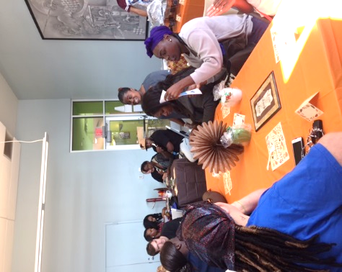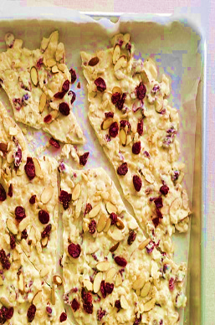

You’re an All Star!

We would like to take this time to thank all

of the parents who attended and volunteered at the recent Health Care Institute (HCI) trainings. Through all of your hard work and support, we were able to reach dozens of families in the community. We would also like to extend a special thanks to all the center coordinators and staffers who worked day in and day out to make this a success. Together we will continue to build capacity and inspire change in our schools, homes and communities.

Thank you!

**More Get Up & Go…**

**All Events are Free of Charge!**

**12/2-01/01-** Celebration in the Oaks

**12/10** – Breakfast with Santa in Kenner’s Rivertown

**12/17** – Arts Market of New Orleans at Palmer Park

**12/18** – Holiday in the Park – Christmas Lights Display in Lafreniere Park

**12/27** – Snuggles and Struggles New Parenting Group at the Parenting Center

**12/31** – New Year’s Eve Kids’ Countdown to Noon at the New Orleans Children’s Museum

**Doll & Toy Fund**

**Saturday, December 17, 2016**

**Xavier University’s Convocation Center**

**7900 Stroelitz Street, NOLA**

**\*\*Free Admission\*\***

**Holiday Health Update**

While Santa may be on his way, he wants all families to know about the importance of toy safety. When shopping for the perfect gift it is important to remember these tips:

1. Make sure the gift is age appropriate.
2. Read all instructional labels and warnings.
3. Check toys for any small parts that may become choking hazards.
4. Painted toys should be covered with lead-free paint.
5. Keep an eye on the kids while they play****

Is your child transitioning out of the LSU Early Head Start Child Care Partnership Program this school year? **If so, let’s discuss your options!**

**For more info, please contact Ms. Raynell Washington.**





**OneApp Main Round Close - February 24, 2017**

**OneApp Placement Results Available - Week of April 10, 2017**

**Child Care Assistance Program**

[**https://cafecp.doe.louisiana.gov/edselfservice/**](https://cafecp.doe.louisiana.gov/edselfservice/)

Hey Now!

**Early Head Start HCI Highlights**

**EnrollNOLA – OneApp**

[**https://enrollnola.org/**](https://enrollnola.org/)

**Let’s Talk**

**White Chocolate Holiday Bark**

Ingredients

1 cup of sliced almonds

¼ cup of unsweetened coconut

1 cup of oven toasted rice cereal

1 cup of dried cranberries

1 ½ lbs. of white chocolate, chopped

2 teaspoons if vegetable oil

Directions

1. Preheat the oven to 325°. Line a baking sheet with parchment paper.

2. Spread the sliced almonds and the unsweetened coconut in an even layer on the baking sheet. Toast 5–8 minutes or until coconut just begins to brown.

3. In a large bowl, combine almonds, coconut, rice cereal, and dried cranberries. Reserve about 1/4 cup of the mixture, and set aside.

4. Place chopped white chocolate and 2 teaspoons vegetable oil in a large heatproof bowl, and set over a medium saucepan of simmering water. Stir with a spatula until the chocolate is completely melted.

5. Remove the chocolate from heat, and fold in the almond mixture. Spread mixture evenly on parchment-lined baking sheet. Sprinkle on the reserved 1/4 cup topping. Refrigerate for about 30 minutes or until the chocolate has completely set. Break the bark into small pieces, and serve.

**The Times Picayune**

**Doll & Toy Fund**

Families with children

12 years and under (no ticket required) **\*\***every child 12 yrs. and under guaranteed a toy**\*\***

