

November kicks off the holiday season with high expectations for a cozy and festive time of year. November is also a good time to reflect on the benefits of gratitude and how to increase one’s expression of thanks.
Gratitude is a thankful appreciation for what an individual receives, whether tangible or intangible. With gratitude, people recognize the goodness in their lives. It helps people connect to other people, nature or a higher power. Research shows that gratitude is associated with greater happiness.
Gratitude helps people feel positive emotions, enjoy good experiences, improve their health, deal with hardship, and build strong relationships.
Harvard Health Publications 2011

November 2016
2nd Policy Council Meeting 4:30p
8th Election Day
11th Veterans Day
16th Parent Committee Meeting
5:00p Kid’s
16th Parent Committee Meeting
4:30p McMillian’s
16th Parent Committee Meeting
4:15p Toddler’s
17th Parent Committee Meeting
4:00p Clara’s
24th Happy Thanksgiving

EHS Closures & Early Dismissals

Clara’s Little Lambs
21st- 25th Closed
29th Early Dismissal
Kids Kingdom Academy
22nd Early Dismissal
23rd-25th Closed
McMillians First Steps
24th- 25th Closed
Parent Teacher Conference Nov. 7th-10th
Toddler’s University
Parent Teacher Conference Nov. 10th @ 12:45p
23rd - Early Dismissal 12:45p
24th- 25th Closed

Monthly Newsletter of LSU Early Head Start
Child Care Partnership Program Volume 2 Issue 3

Giving ‘thanks’ can make you happier!
It can be felt and expressed in many ways. One can reflect on past blessing or be thankful for positive memories. One can also focus on the present and be aware of one’s good fortune as it comes.

Gratitude is a way for people to appreciate
what they have instead of always reaching for something new in the hopes it will make them happier, or thinking they can't feel satisfied
until every physical and material need is met.
It helps people to refocus on what they have instead of what they lack.

Let’s show a little gratitude today! It may feel a bit unnatural at first, but the more you practice expressing gratitude the happier you’ll become. There are many ways you can express gratitude; start by writing a thank-you note, keeping a gratitude journal, giving a hug or a compliment, or simply being a listening ear.

Message from the EHS Director

LSU EHS-CCP program is appreciative for all of our families,
teachers and staff. Thank you, EHS teachers for doing the most important work of all – educating the next generation. Thank you for modeling patience, honesty, courage, perseverance, wisdom, responsibility, generosity, and a commitment to lifelong learning to the best of your ability each and every day in your classroom. Most of all, thank you for everything you have done and will continue to do to create a better future.





Toddler’s University Fall Festival 2016
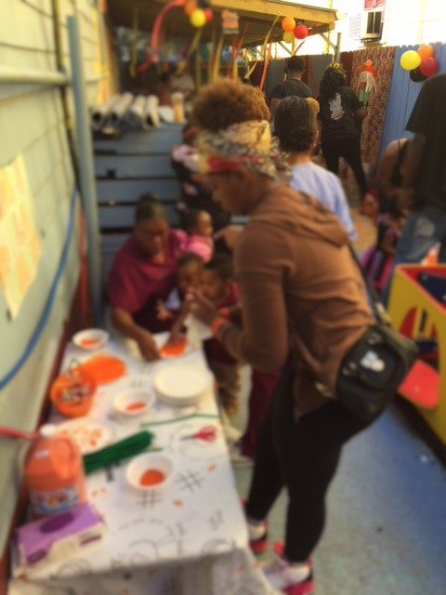

Is your child transitioning out of the LSU Early Head Start Child Care Partnership Program this school year? If so, let’s discuss your options!

For more info, please contact Ms. Raynell Washington.

OneApp Main Round Launch - Week of November 1, 2016

OneApp Main Round Close - February 24, 2017

OneApp Placement Results Available - Week of April 10, 2017

Work somewhere you
Seasonal Careers
Macy’s
Apply at www.macysJOBS.com
Target
Apply in store or www.target.com/careers
JCPenny
Seasonal /Permanent Sales Associate
(Oakwood/Lakeside)
www.jobs.jcp.com
Gap Inc.
Banana Republic (Canal Place)
https://jobs.gapinc.com/
Dillard’s
Sales Associate/Sales Support
(Oakwood/Lakeside)
http://careers.dillards.com/Careers/

Ms. Randle enrolled into Kids Kingdom
Academy in 2015 and has recently
graduated from New Orleans Job Corps
Culinary Arts program. Ms. Randle was a model student who managed to complete the 6-9 month training program in only 4 months. She was chosen as her graduating class Valedictorian speaker of ceremony.

Ms. Randle was a member of the SGA, winner of the 2016 Job Corps annual cook-off and an active participant in the program’s Restaurant Week events. She is an active community volunteer and loves to cook for those in need. Ms. Randle says that Job Corps was a rewarding experience that has provided her with lots of great opportunities. She would do it all over again if giving the opportunity!
As for Kids Kingdom Academy, she says they are her family away from home and appreciates how they motivated and encouraged her throughout her journey.

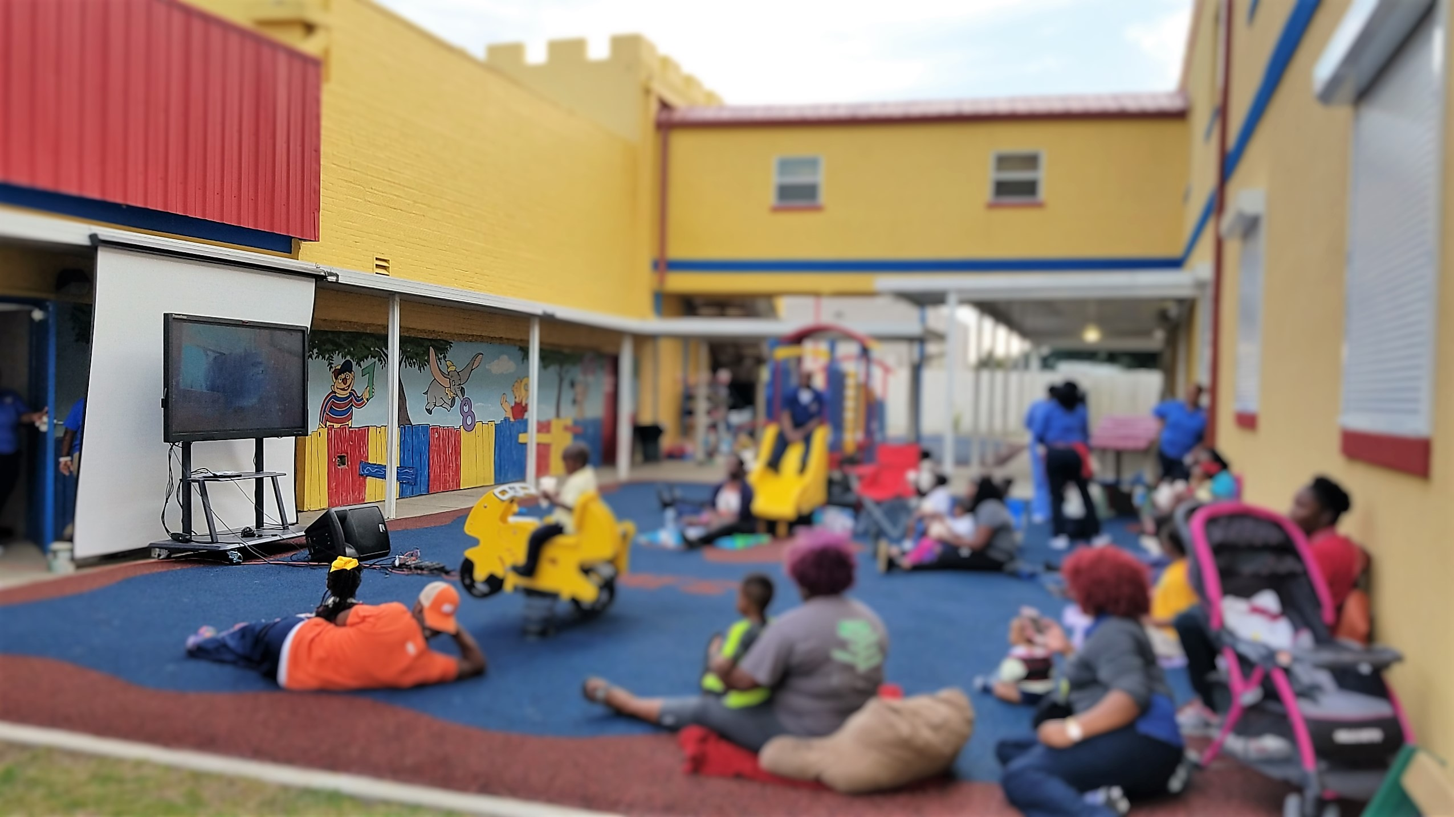

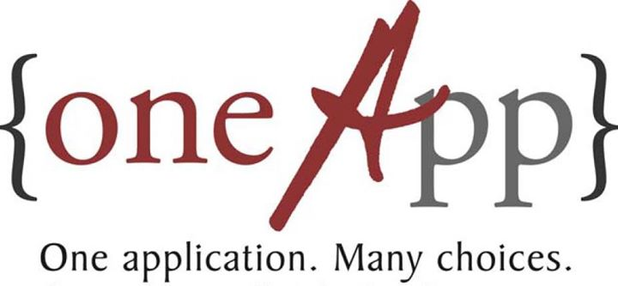

Let’s Talk

Child Care Assistance Program

https://cafecp.doe.louisiana.gov/edselfservice/

EnrollNOLA – OneApp

https://enrollnola.org/

McMillian’s Movie Night 2016

Sweet Potato Cubes
Super easy, healthy side dish that kids love! Servings are kid-sized or snack sized.

Ingredients
Servings 2-4 Units
1 sweet potato, scrubbed and peeled
1 teaspoon cinnamon-sugar mixture
Directions
- Dice the potato into 1 inch cubes and toss with the cinnamon and sugar.
- Spray a baking sheet with
cooking spray then spread
potato cubes over it. Spray
cubes again with cooking
spray.
- Roast for 30 minutes in a 350ºF oven.



The Times Picayune
Doll & Toy Fund
Families with children
12 years and under (no ticket required) **every child 12 yrs. and under guaranteed a toy**

Doll & Toy Fund

Saturday, December 17, 2016
Xavier University’s Convocation Center
7900 Stroelitz Street, NOLA
**Free Admission**




Clara’s Little Lambs Halloween 2016

