Quick Guide to Microsoft Forms for HDC Users

Microsoft Forms is an application, part of Office 365 that enables the user to create surveys, polls, online application forms, and more. This guide will re-create to some extent the LEND Self-Advocate and Family Member Application as a Microsoft Form.
To begin, go to forms.microsoft.com. You will need your LSUHSC e-mail and password to sign in if you aren’t already signed in.
If you are signed in properly, you should see your Microsoft Forms dashboard. Yours will look different from this because this one displays many existing forms.
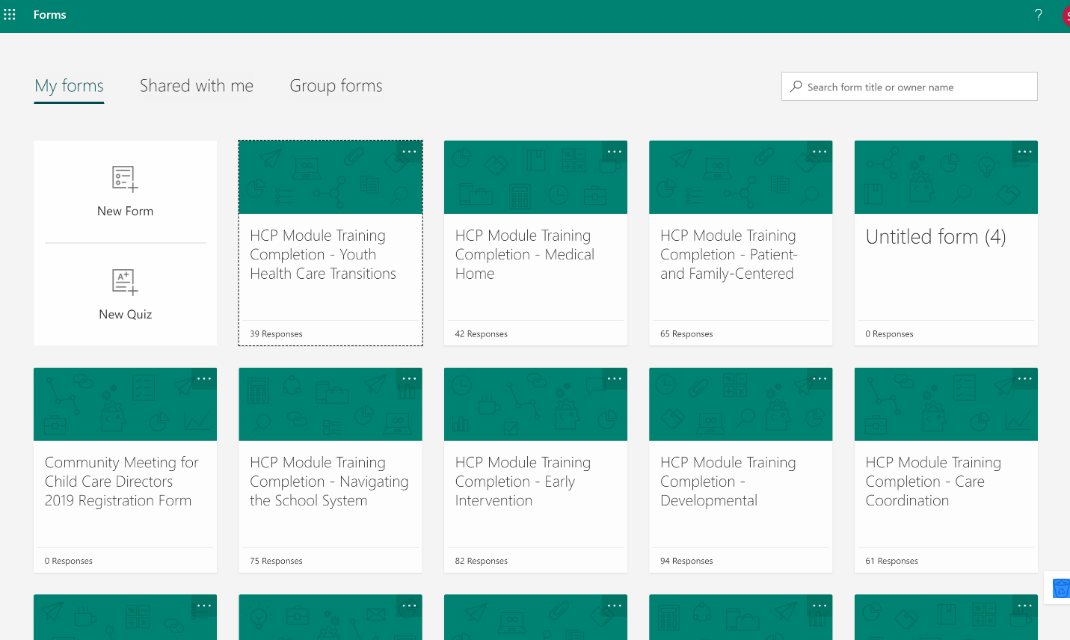
Create the form by clicking “New Form.”
You will be taken to the Form Designer.
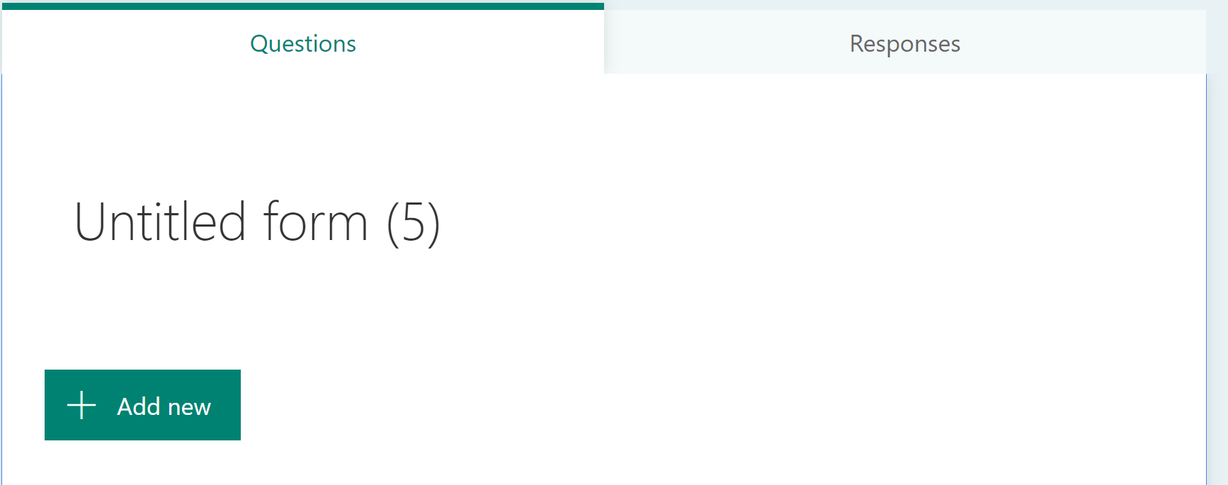
The large text between the tabs and the “Add New Question” button is the title of the form.
Click the title to change it.
The form is automatically saved.
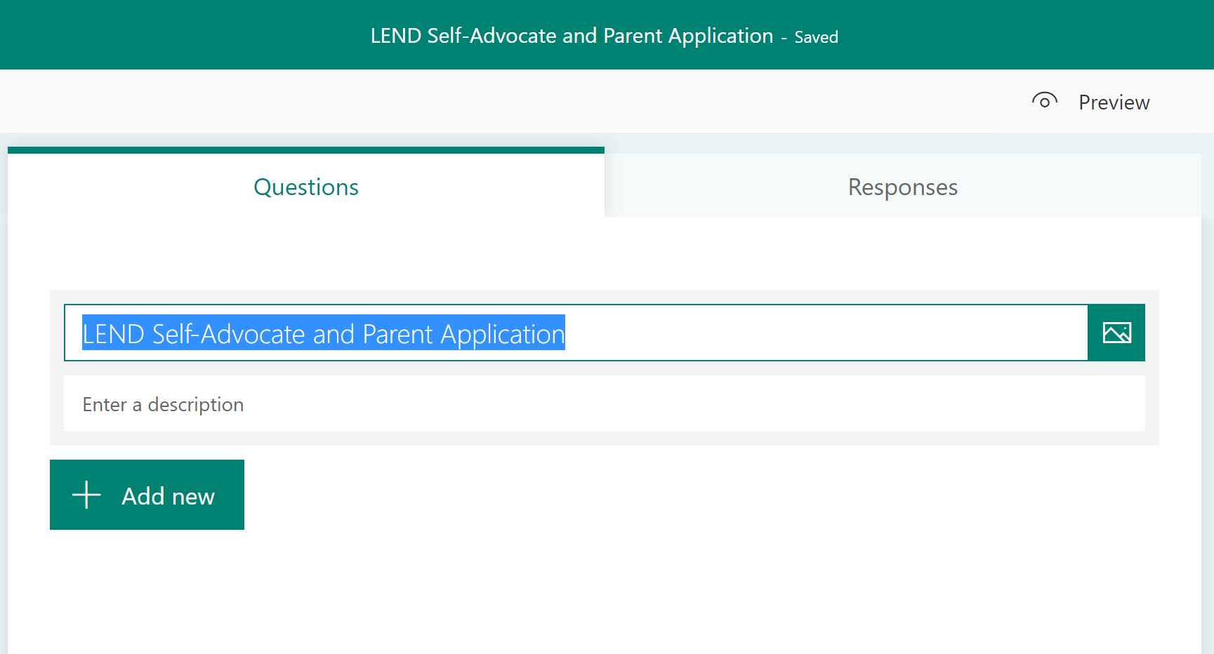
You might notice that you can also add an image to the header of the form by clicking the button to the right of the title, or that you can add a description to the form. We will leave those alone.

Adding a question

When you click the “Add New” button, you will see the available question types. If you want even more question types, you can click the down-arrow button at the far right.
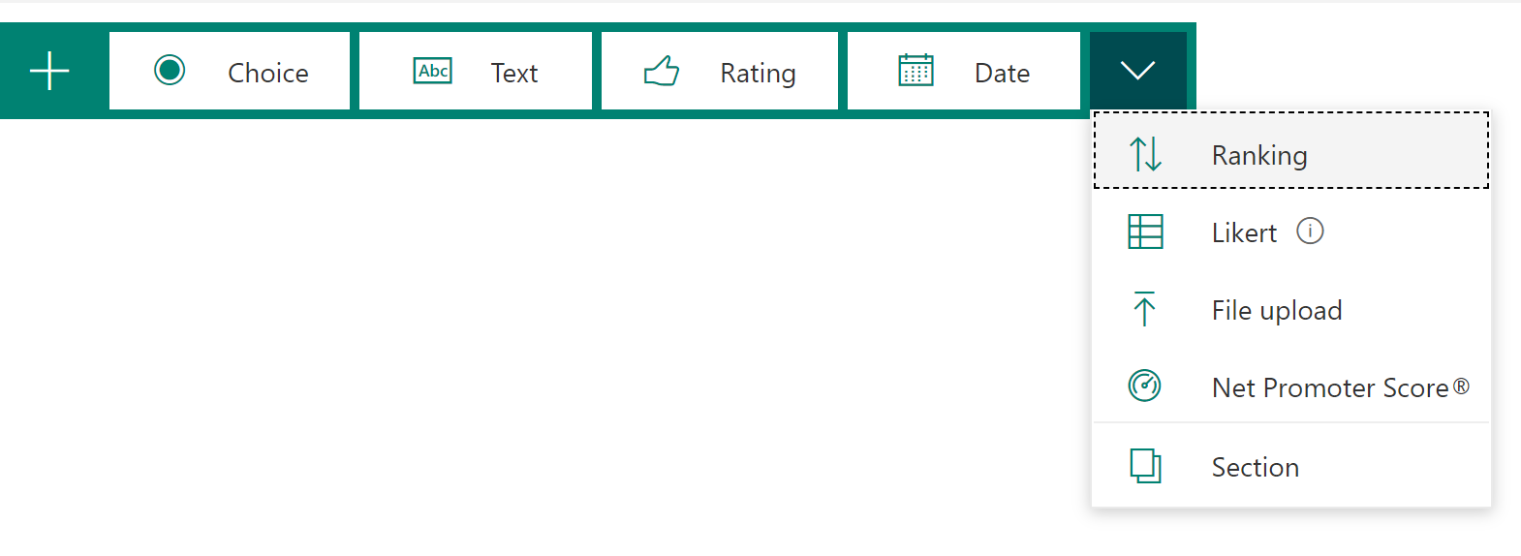
For the purposes of this guide, we will stick to the “Text,” “Choice,” “Date,” and “Section” types.
A Section is a grouping of fields. All fields between one Section field and the next, or between the last Section field and the end of the form, are considered to belong to the Section field that precedes them.
The options for a Section field are the same as those for the form’s heading. Create a Section field called “General.”
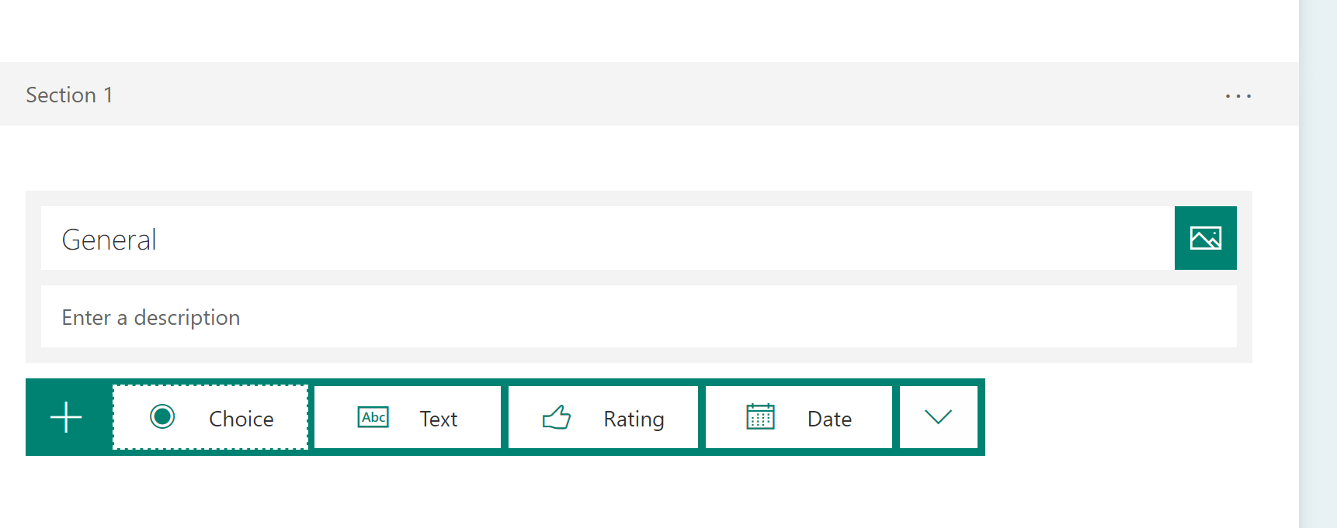

Adding a text question

We are ready to start adding actual questions.
The first question is a text question labeled “Name.” It should be marked as required.
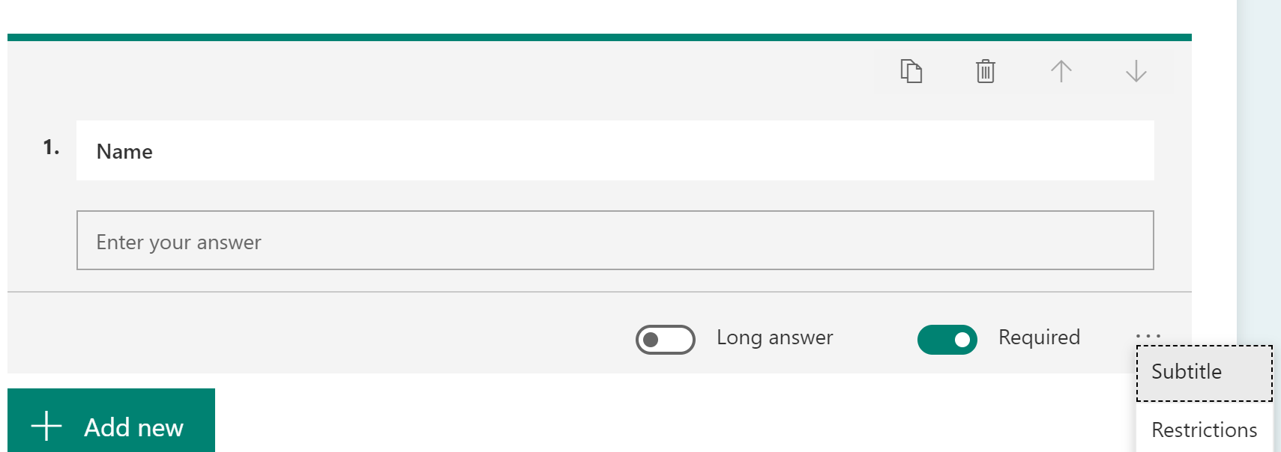
NOTE: The screenshot above shows that by clicking on the ellipsis (…) menu, you will see options for “Subtitle” and “Restrictions.” We will use them later.
If you now try to add another question, you might see this:
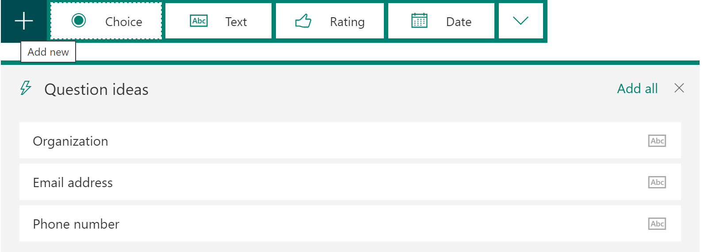
If you see it, ignore it; we will be adding those fields later.

Adding a date question

Next, we will add a date field, simply labeled “Date.” It is not necessary to mark it as required, as the date of submission will be used as a fallback.
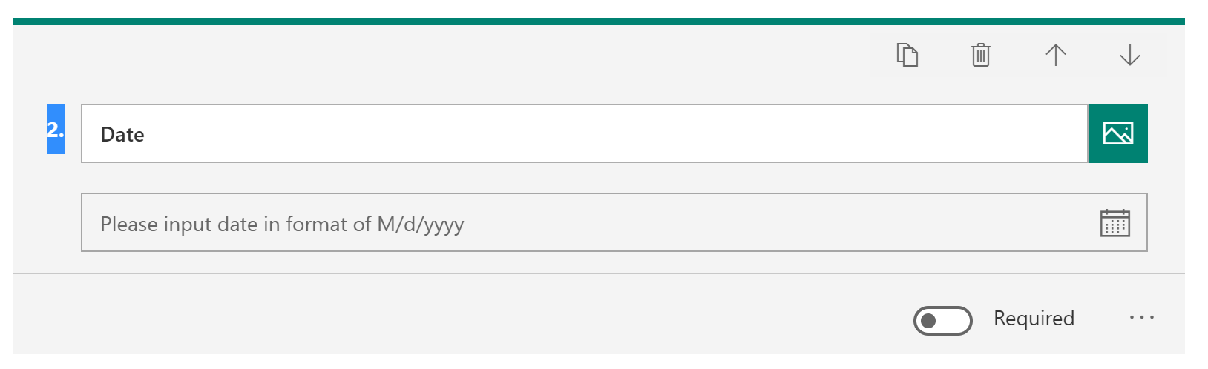

Adding a question with a subtitle
Next, add a question with the title “Alternate E-mail.” (This guide focuses on a subset of the original fields, but a non-LSUHSC e-mail address is essential if you plan to continue on to the Microsoft Power Automate tutorial. That tutorial will use this form. Note that this field has a subtitle. Microsoft does not validate e-mail addresses, so the subtitle is a reminder to put in the FULL e-mail address.
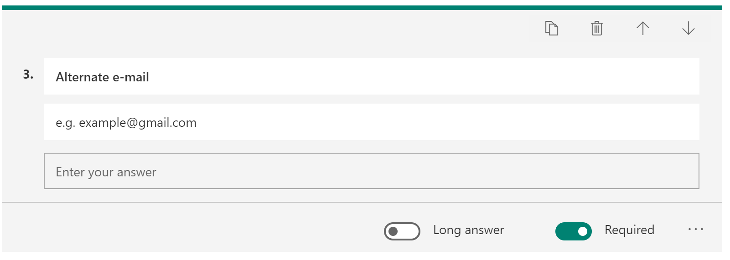

Adding a choice question (and branching)

Finally, we will focus on the Gender question, or rather, pair of questions. Enter the first Gender question and the choices as seen below. (NOTE: A drop-down list is possible from the ellipsis menu, but not if multiple choices are allowed.)
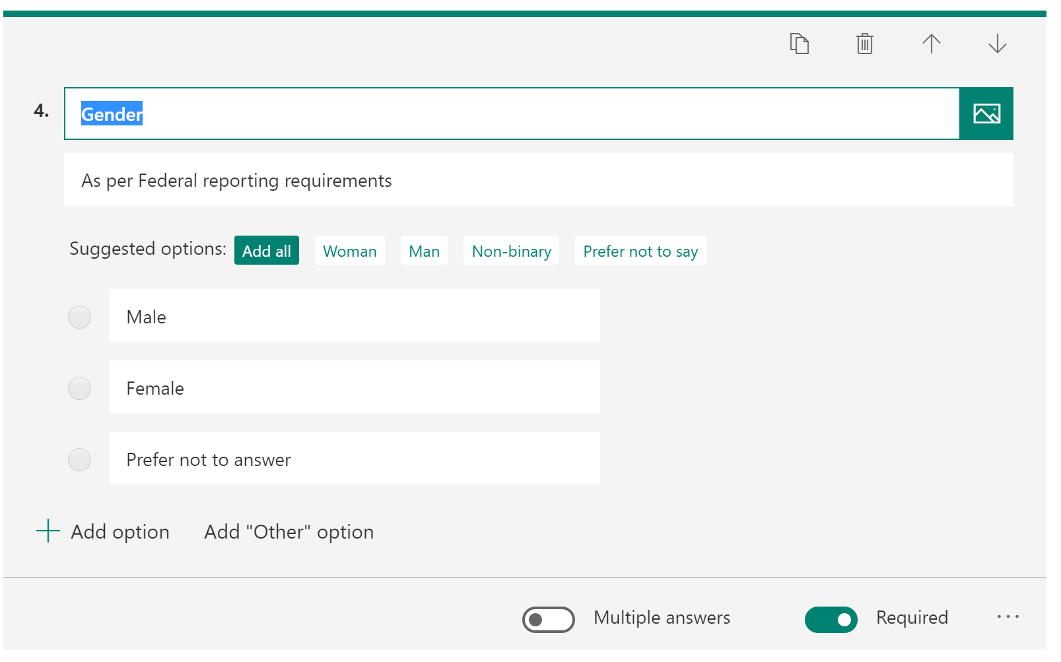

Finally, we will illustrate branching by including the other gender question (a text question):
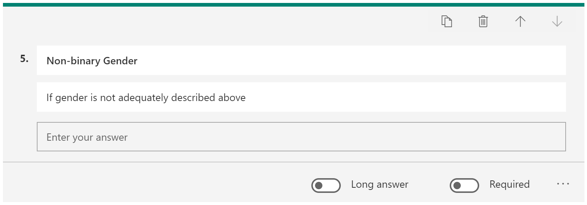
Branching is a form setting, accessible from the main form ellipsis menu:
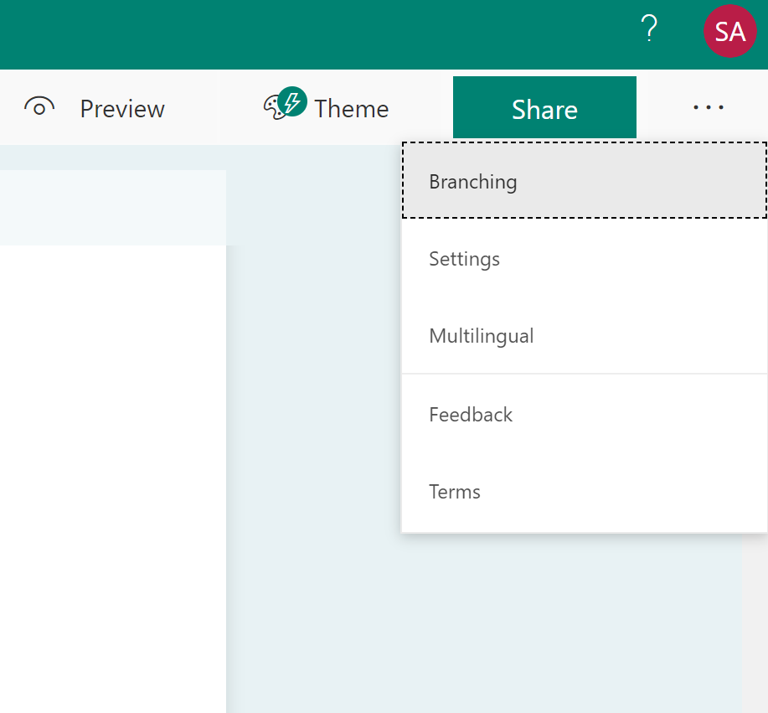
Let’s assume that somebody is OK with answering their gender, and that they would be OK with answering question 5 only if they also reported their gender according to federal regulations. This means if they answer “Prefer not to answer” to question 4, then they should be taken to the end of the form.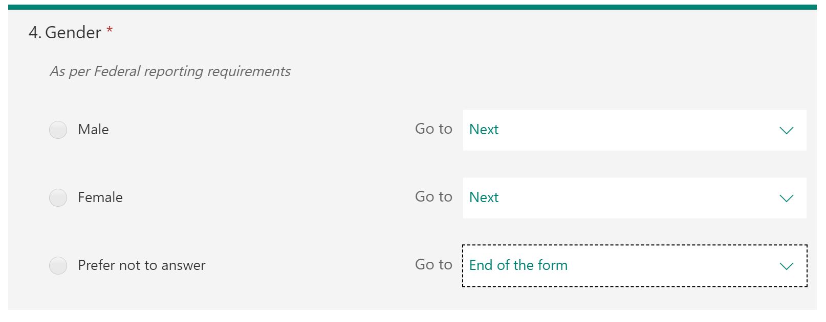

Testing the form
To test the form, use the Preview button. Our response will actually be recorded for the form, so we will clear it out later.
Leave the “Name” and “Alternate e-mail” questions blank for now.
Focus on the Gender radio question. Observe how the other Gender question appears when “Male” or “Female” is selected. That is the result of our branching logic.
Press “Submit” and observe that some red areas appear on the screen. These are the required questions. Observe that the red areas disappear as soon as a character is entered in any of them. Enter some text in both of them.
If you click “Submit” now, you should see that you are successful and get a message.

Clearing responses
Finally, we will delete our test responses. To do that, go back to the form editor and click the Responses tab. Then click the ellipsis menu as shown.
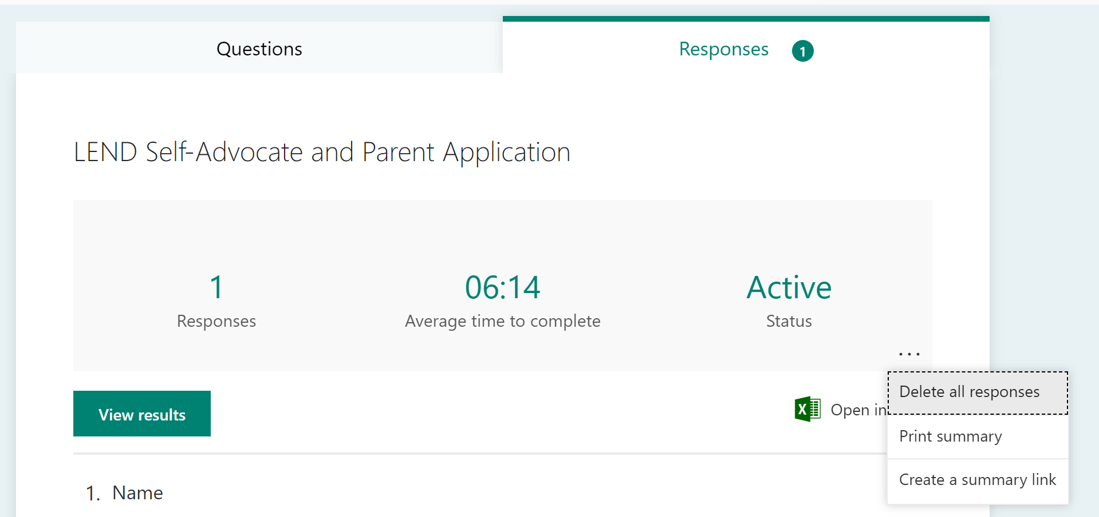
You are now finished with this Quick Guide on how to create a Microsoft Form.

