# WebAIM Contrast Checker Activity

## Image for Activity:



## Goal:

See which color combination of the dots pictured above pass the WCAG accessibility standards.

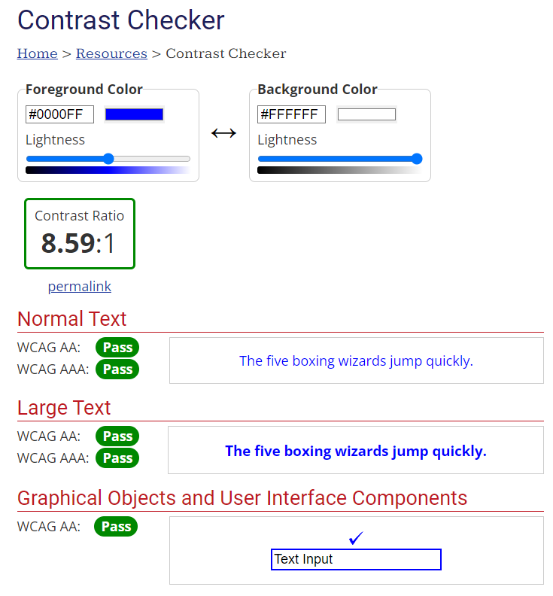

## Instructions:

1. Open <https://webaim.org/resources/contrastchecker/> (You cannot use Mozilla Firefox for this activity)
2. In the Contrast Checker, click the color box of the foreground color

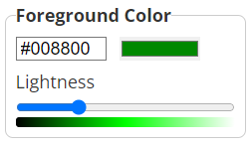

1. Click the eyedropper

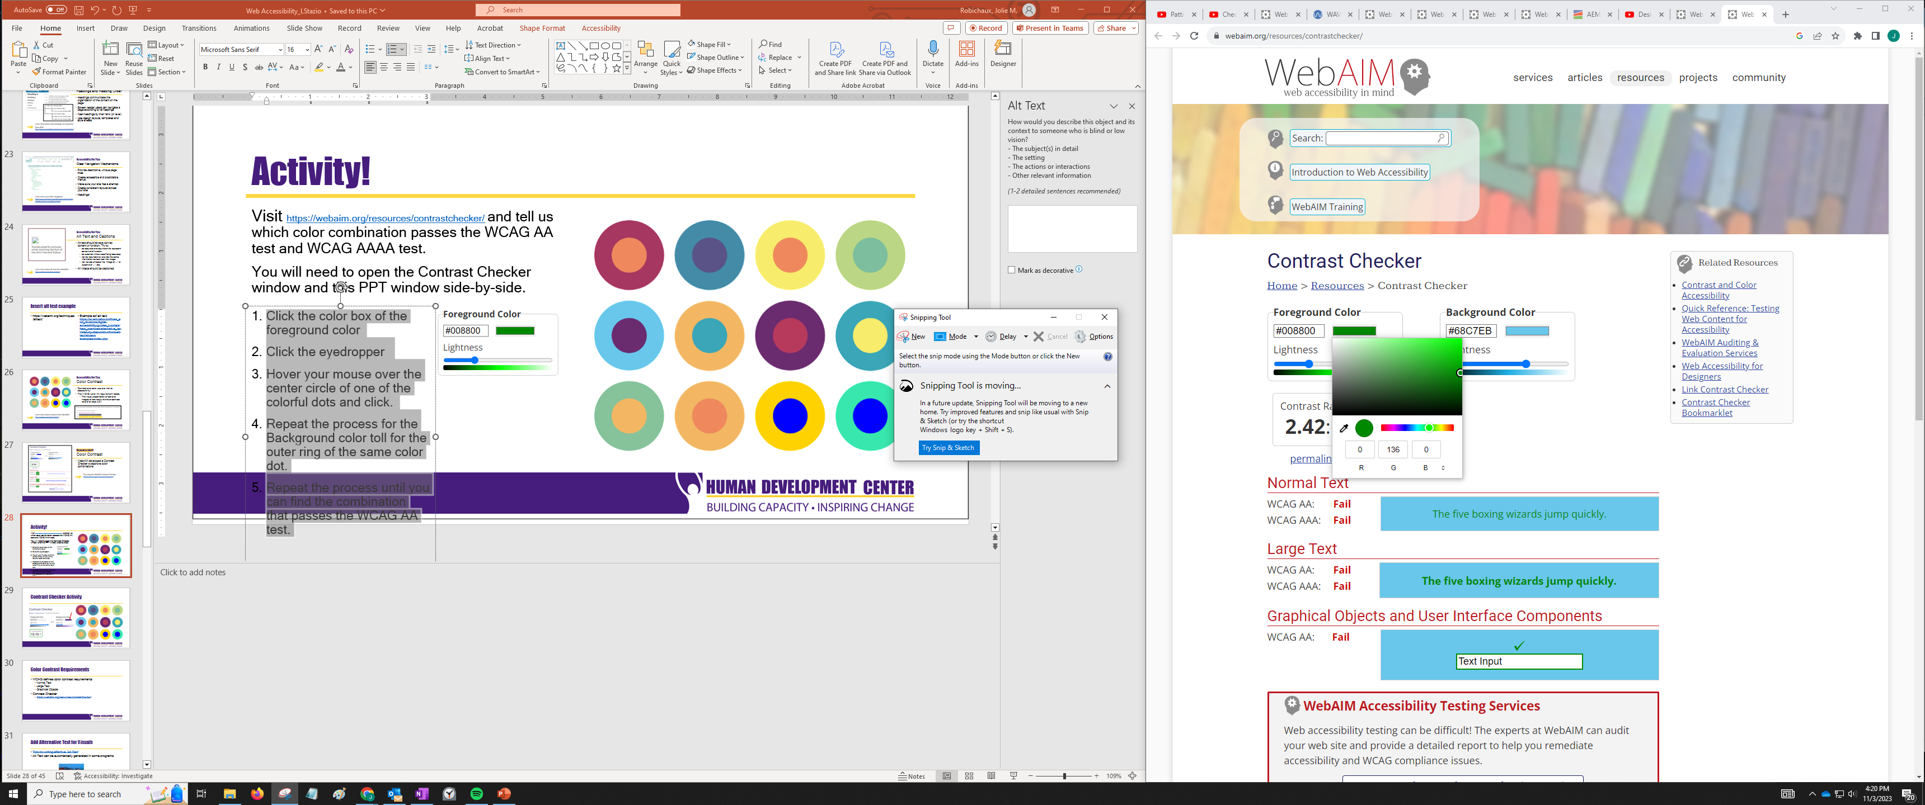

1. Hover your mouse over the center circle of one of colorful dots below and click.
2. Repeat the process for the background color of the same color dot.
3. Repeat the process until you can find the combination that passes the WCAG AA test.